**INSTRUCTIONS FOR INSTALLATION OF FREE GPT CHAT**

**STEP 1 :**

Download file Chat GPT

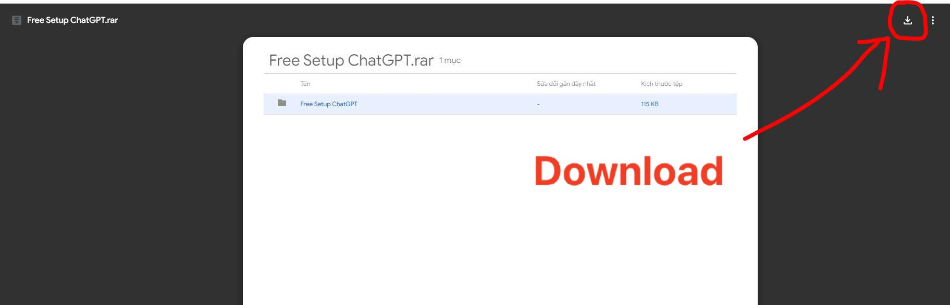

**STEP 2 : Unzip the file**

*Unzip the downloaded file to your computer***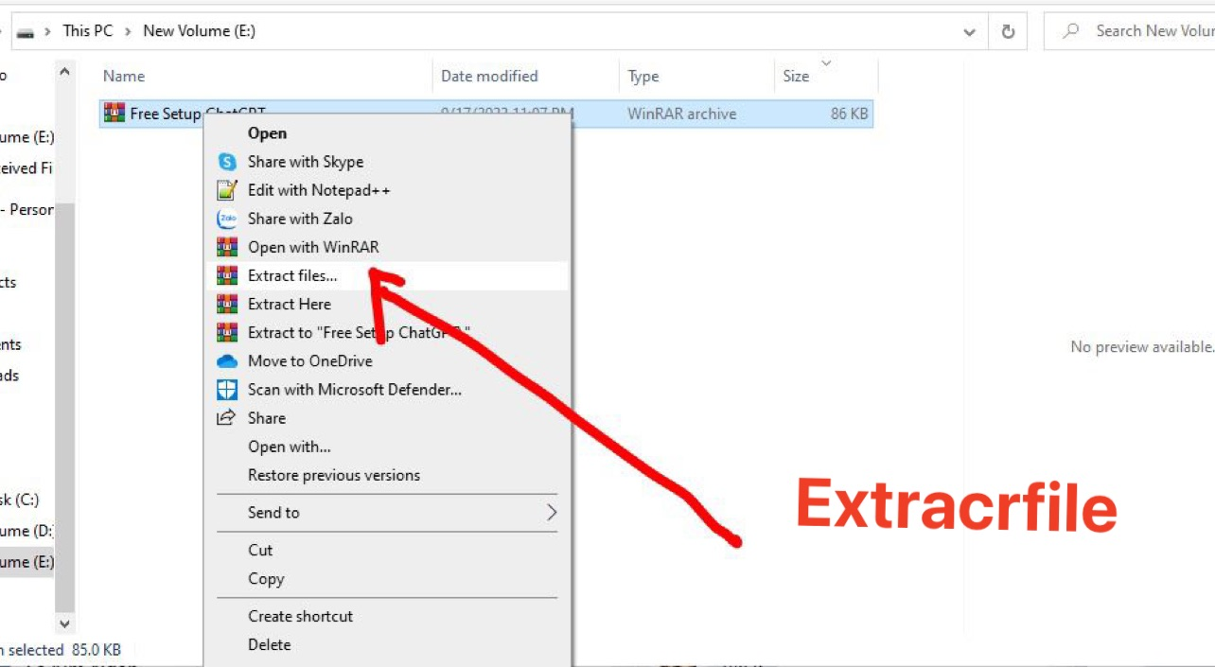**

**STEP 3 : Install gpt chat**

*Click on the extracted file and click twice on chat gpt to automatically install, takes 2-3 minutes***